Please find the below steps to install Zabbix Agent 2 – Version 7.5 for UAT windows servers.

Supported Windows Server Versions:

* Windows Server 2016
* Windows Server 2019
* Windows Server 2022

Step 1]

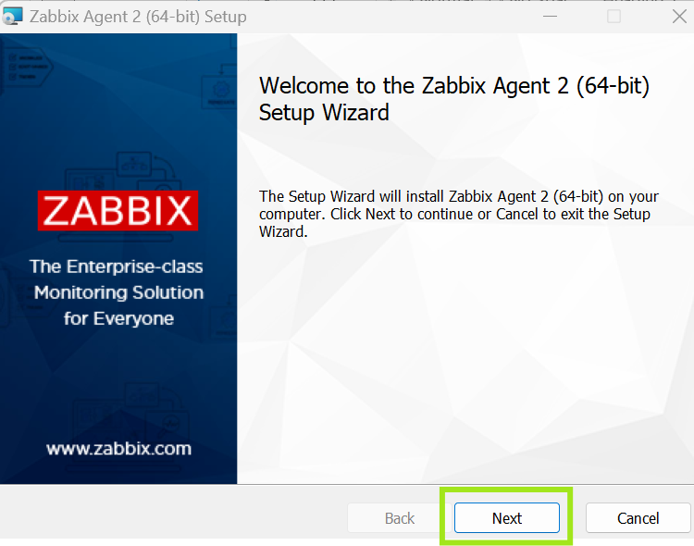

Step2]

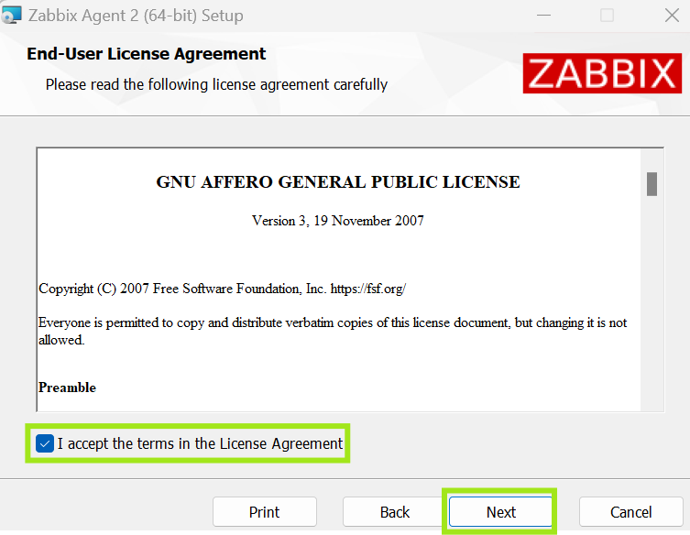

Step3]

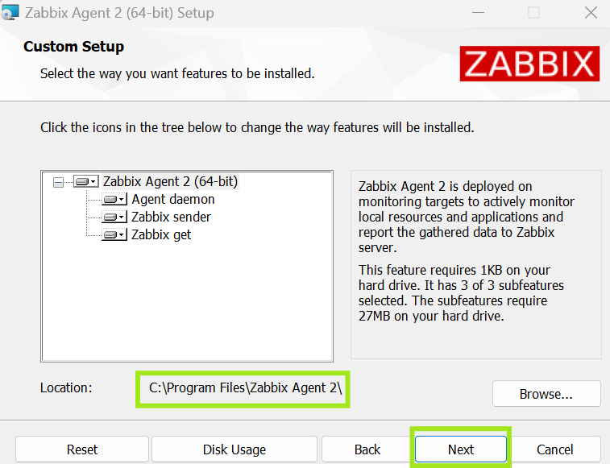

Step4]

3.1] Change the Hostname as server Hostname

3.2] Change the Zabbix Server IP as 184.127.0.66

3.2] Change the active check IP as 184.127.0.66

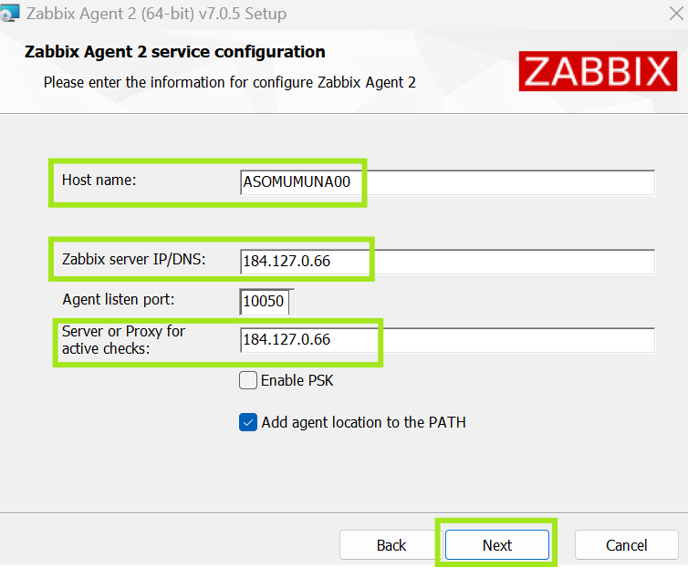

Step5]

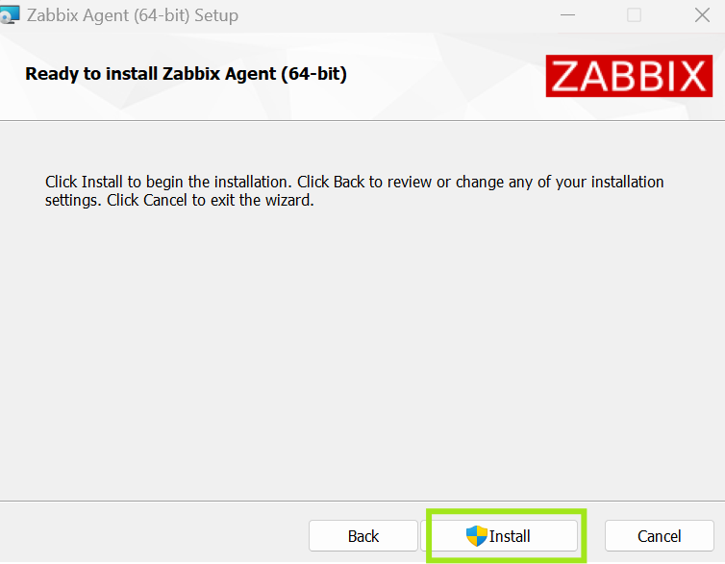

Step 5]

Check the Zabbix service status, Service state should be running

